# “RTO MANAGEMENT SYSTEM”

**A COMPUTER SCIENCE PROJECT REPORT**

**SUBMITTED BY**

DIVYA SHUKLA

**IN PARTIAL FULFILMENT OF THE**

**AISSCE – 2022-23**

**IN**

**COMPUTER SCIENCE (083)**

**AT**



**J.B. DIAMONDS & KARP IMPEX VIDYA SANKUL**

**SCHOOL**

**LASKANA, KAMREJ ROAD, SURAT**

**J.B. Diamonds & KARP Impex Vidya Sankul**

Opp. Diamond Nagar, B/H Thakor Dwar Farm, Surat - Kamrej Road, Laskana

**Phone No: 9228025712, Email id: jbkarpschool.cbse@gmail.com**

**Web: www.jbkarpschool.ac.in**

**CBSE-English Medium**

**This is certify that Mr.\Miss.** DIVYA SHUKLA **is a student of J. B. Diamonds & KARP Impex Vidya Sankul, who has successfully completed the project work on title “RTO MANAGEMENT SYSTEM” in COMPUTER SCIENCE (083) assigned to him\her as a part of AISSCE curriculum during the academic year 2022-23.**

**We found him\her very sincere, hardworking and disciplined girl\boy.**

**We wish all the success for his\her future endeavors.**

**…………………………………………… ……………………………………………….**

**(Signature of the Internal Examiner) (Signature of the External Examiner)**

**…………………………………**

**(Signature of Principal)**

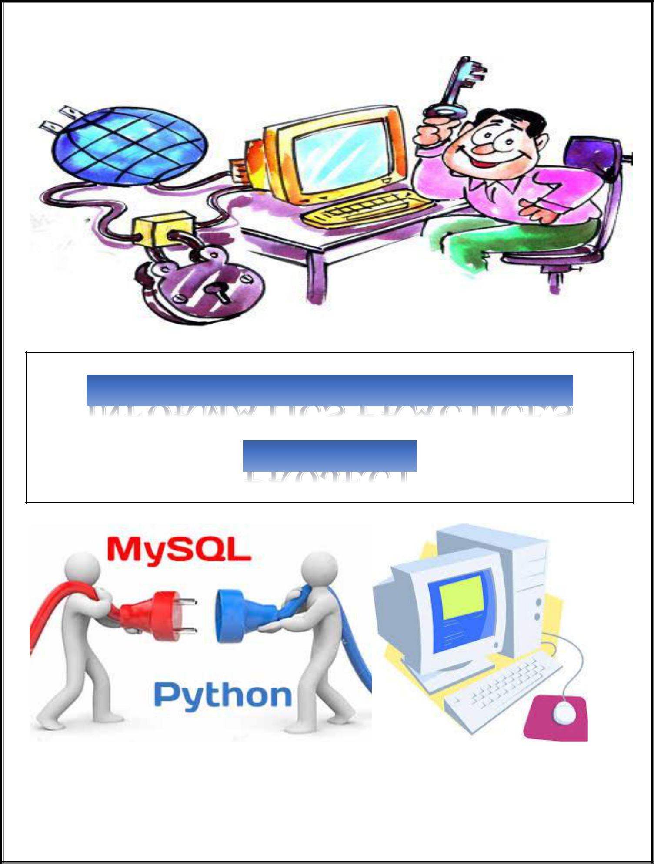

***PROJECT FILE***

Acknowledgement

I would like to express my special thanks of gratitude to my Computer Science teacher Mr. Ajay Tiwari Sir as well as our principal Mr. Gaurang Patel Sir for their guidance and support in completing this wonderful project entitled “ RTO MANAGEMENT SYSTEM ” using Python-MySQL connectivity.

I came to know about many things. I am really thankful to them.

A debt of gratitude is also owed to my parents and friends who helped me with their valuable suggestions.

Although this report has been prepared with utmost care and deep routed interest, even then I accept respondents and imperfections.





**Contents**

CONTENTS

|  |  |
| --- | --- |
| **S.No.** | **TOPICS** |
|  |  |
| 1. | AIM |
|  |  |
| 2. | INTRODUCTION |
|  |  |
| 3. | Python Coding |
|  |  |
| 4. | Database Structure |
|  |  |
| 5. | Input-Output Interference |
|  |  |
| 6. | Bibliography |
|  |  |



AIM

**AimAIM**

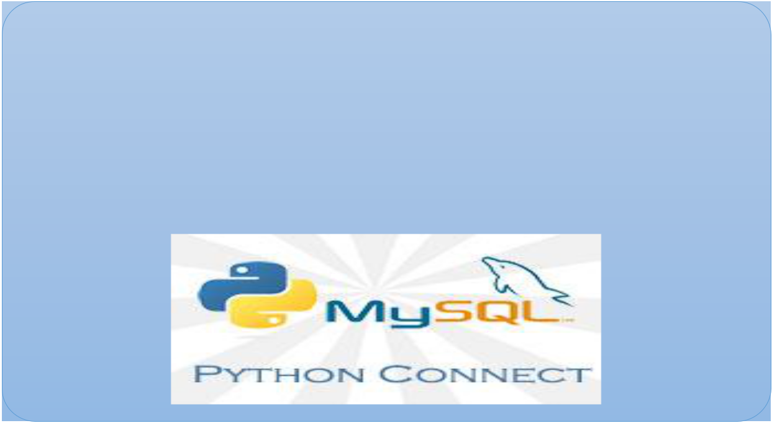

**RTO MANAGEMENT**

**Using MYSQL Connectivity**



**Introduction**

**Introduction**

* **What is Python?**
  + The Python Programming Language is a recent, general-purpose and higher-level programming language. It has features for database programming also.
  + This project aims on explaining how one can create a MySQL database from within a Python script and create a user interface software.
* **Why Python?**
  + - Due to its open source nature, Python has been ported to many platforms.
    - It is free and open source. It is available for free and runs on almost every current platform.
    - Python provides interfaces to all major commercial databases.
    - It can easily integrated with C, C++, COM, Java, MySQL, etc.
* **What is MySQL?**
  + MySQL is a freely available open source Relational Database Management System (RDBMS) that uses Structured Query Language (SQL).
  + It provides you with a rich set of features that support a secure environment for storing, maintaining, and accessing data.
* **Why MySQL?**
  + It is an open source software and is easily portable.
  + It is easy to use, manage and works quickly and efficiently.
  + It is used to create databases, manage security of a database.
  + It maintains integrity and reduces data redundancy.

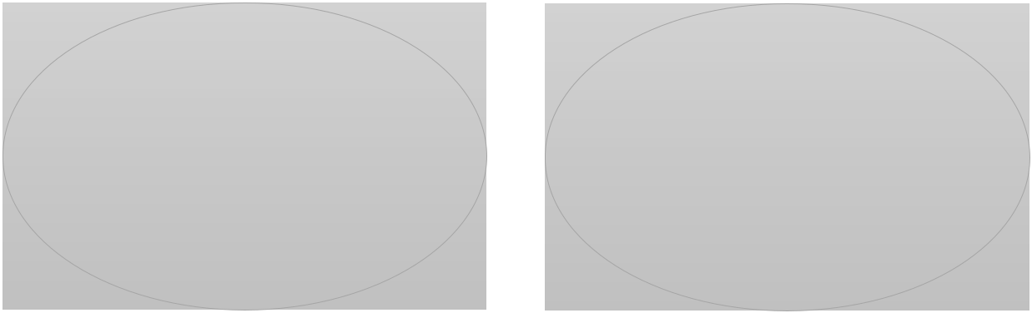

|  |  |
| --- | --- |
| Python is a | MySQL is a |
| Front End | Back End |
| Software | Software |

**Interface Python with MySQL**

There are mainly seven steps that must be followed in order to create a database connectivity application.

**Step 1** –Start Python

**Step 2** –Import the packages required for databaseprogramming.

**Step 3** –Open a connection to database.

**Step 4** –Create a cursor instance.

**Step 5** –Execute a query.

**Step 6** –Extract data from result set.

**Step 7** –Clean up the environment.



PYTHON CODING

LOGIN CODE

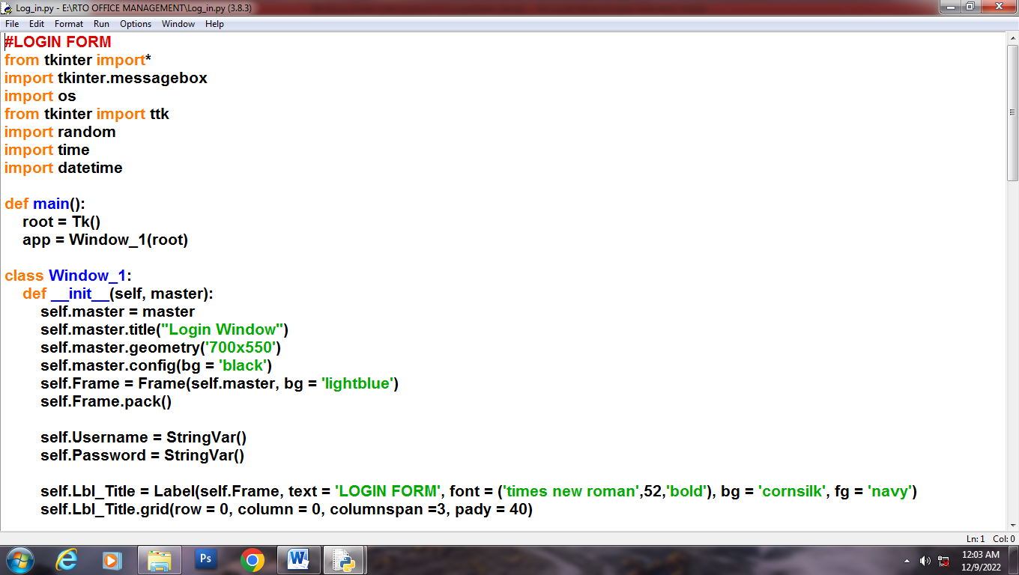

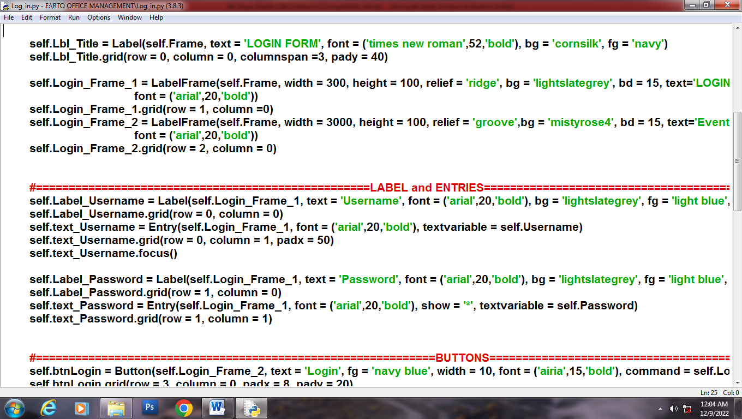

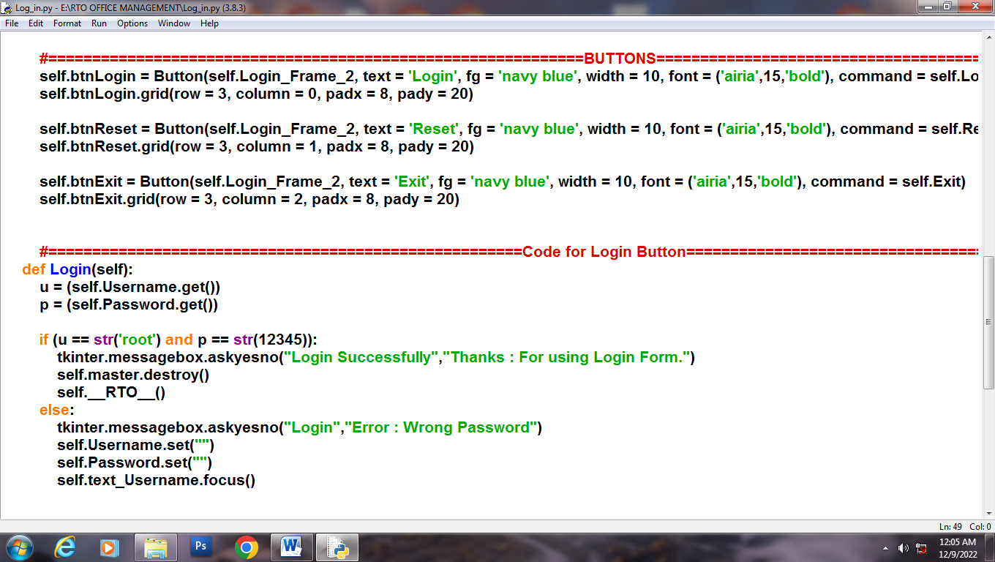

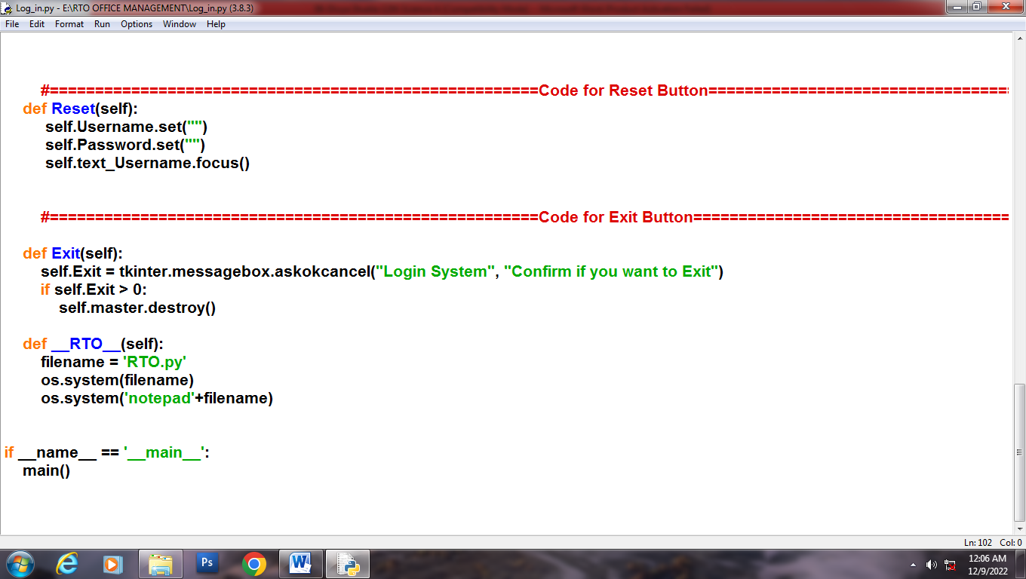

OUTPUT

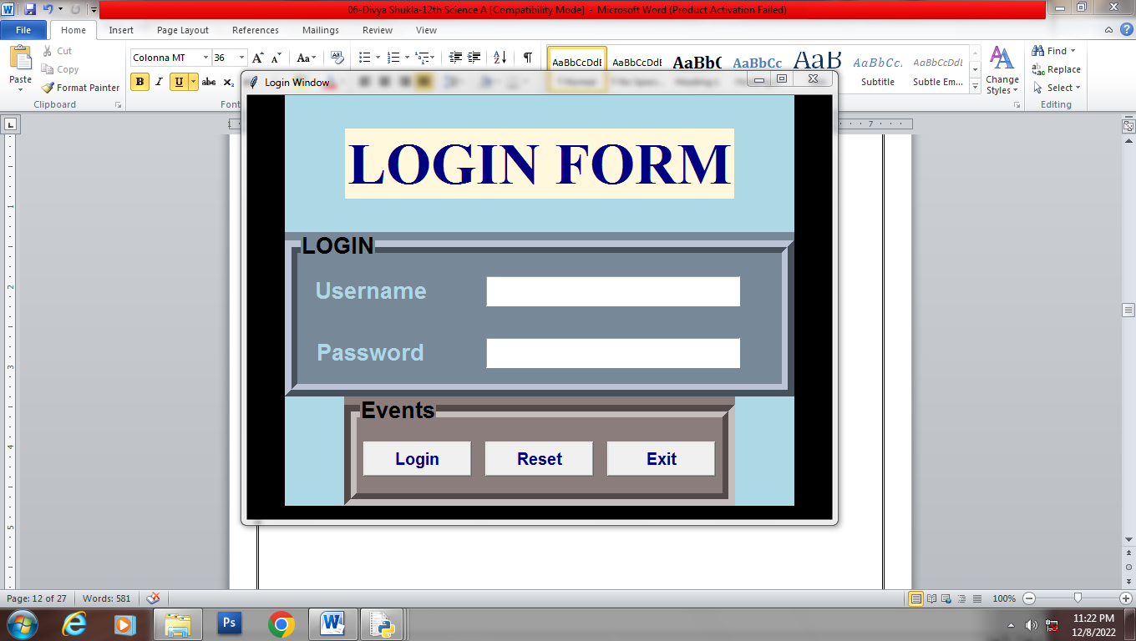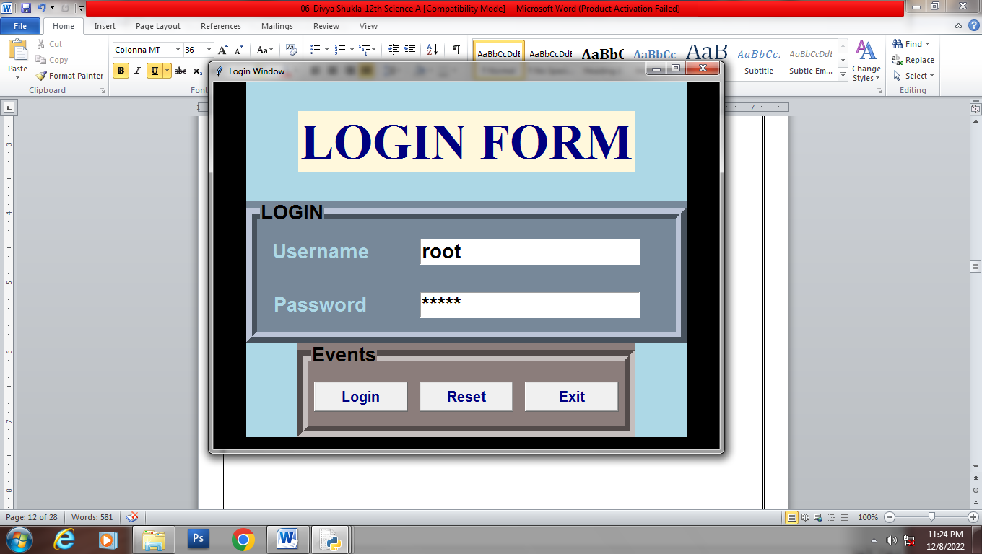

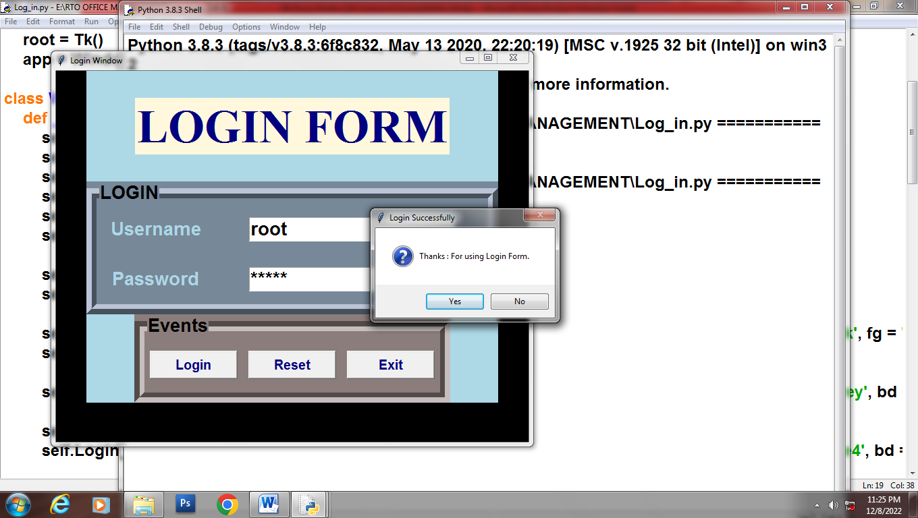

**SOURCE CODE**

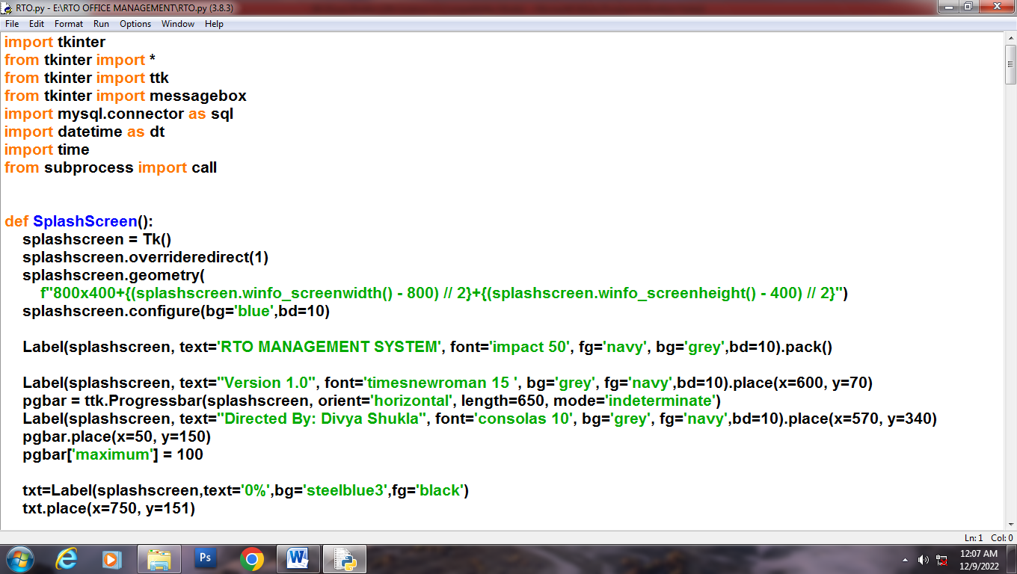

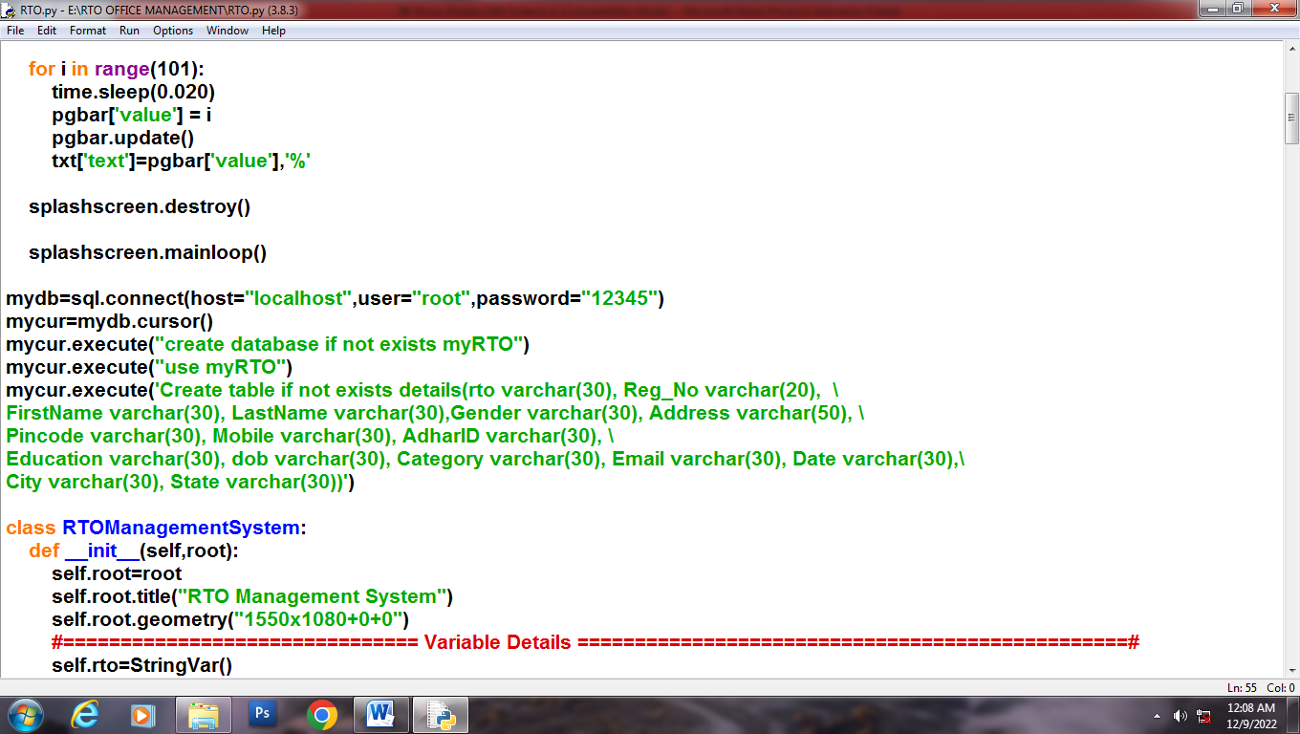

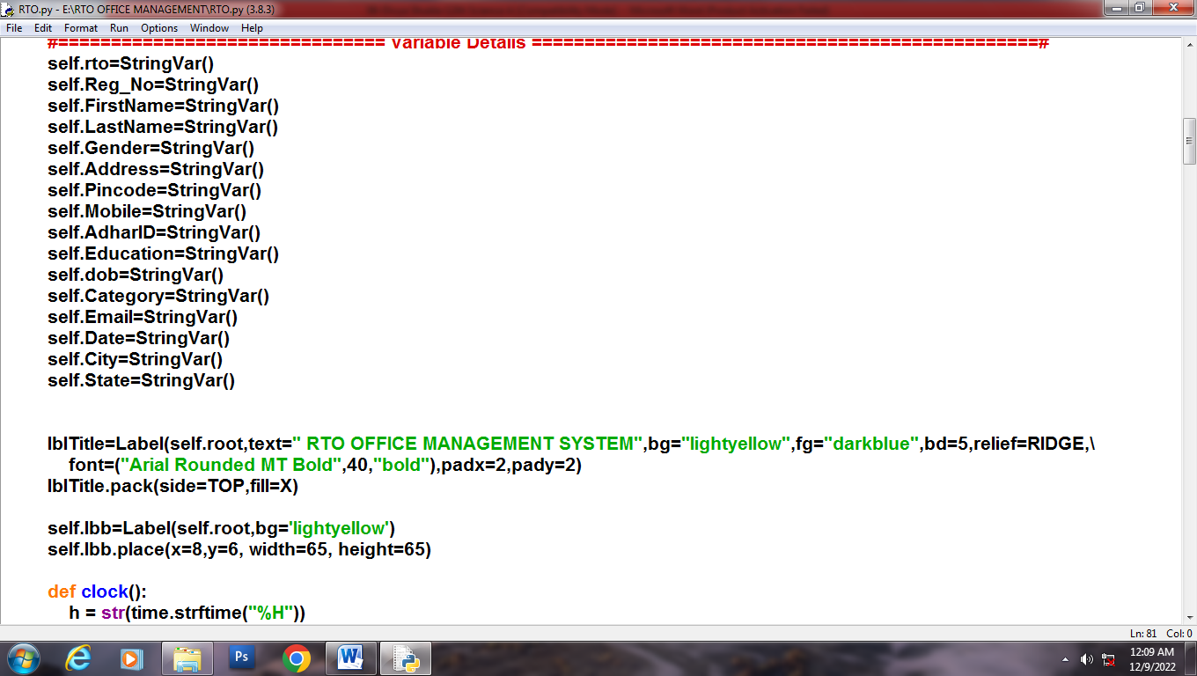

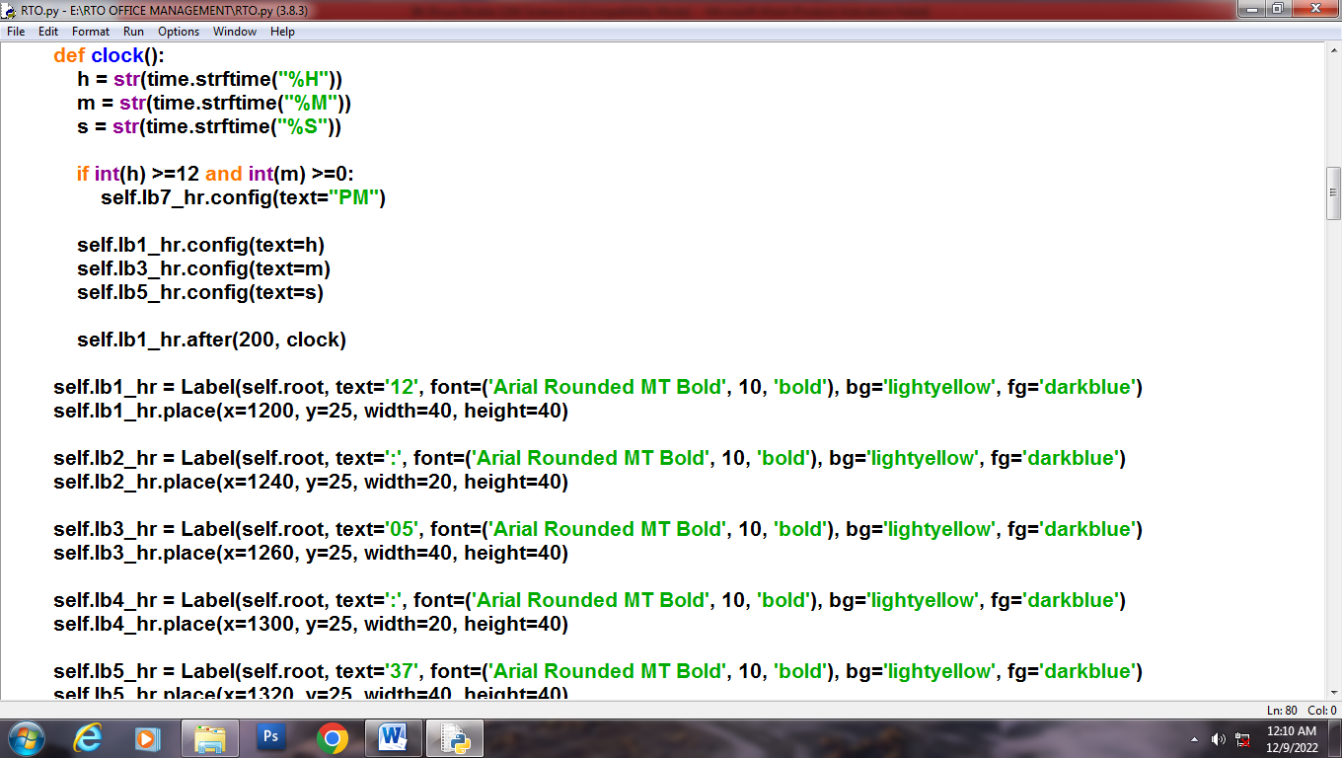

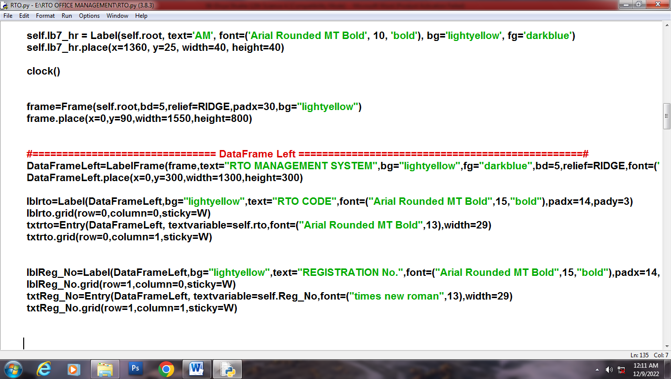

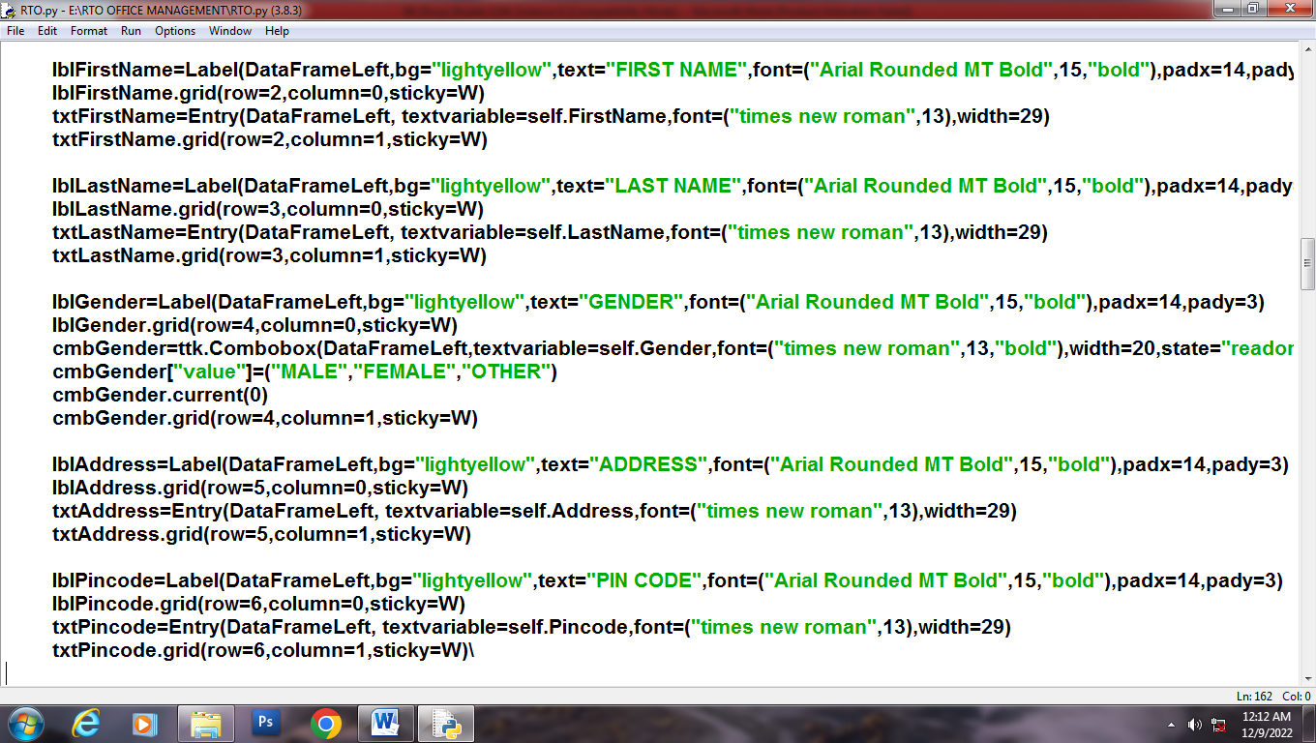

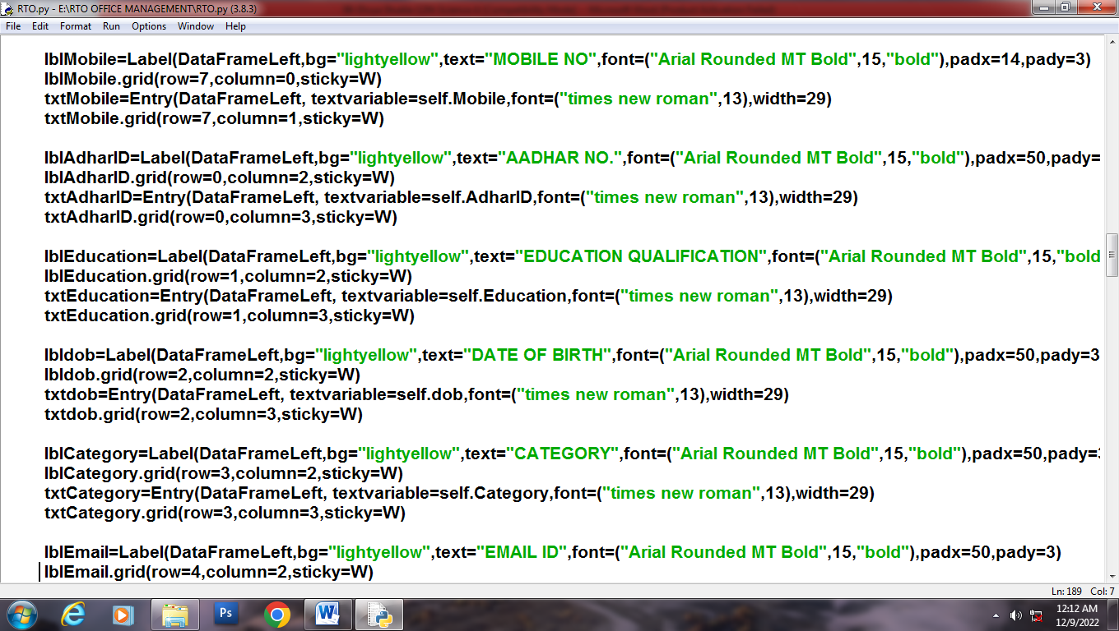

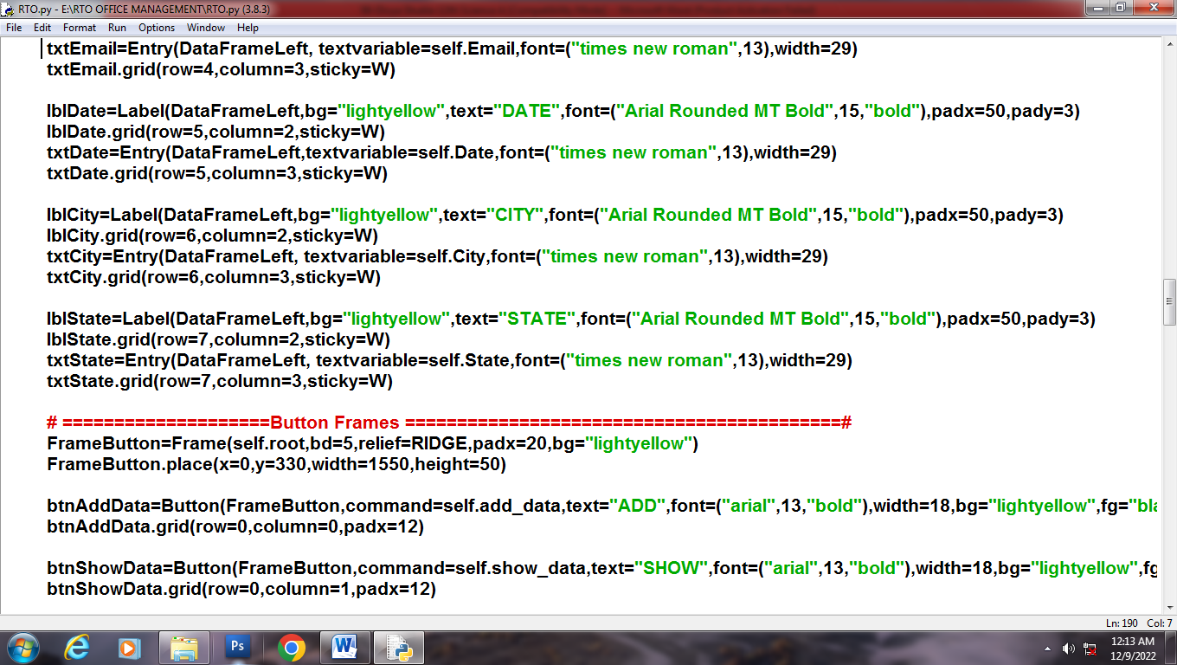

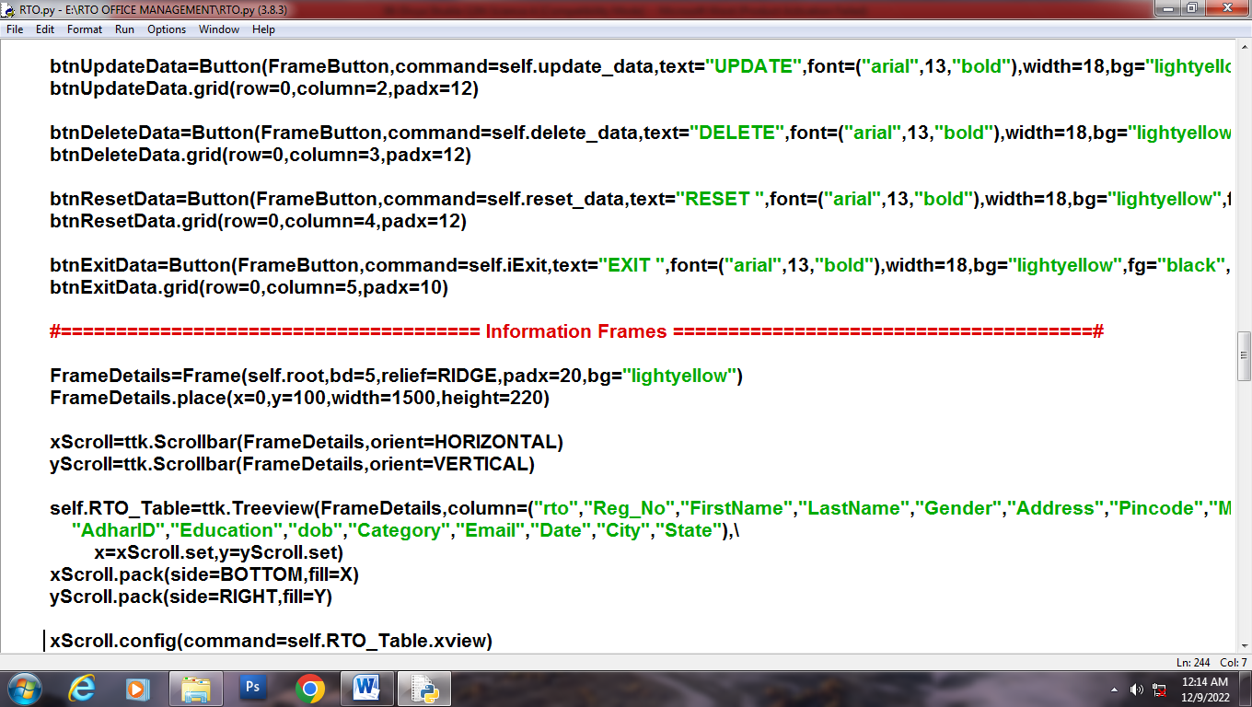

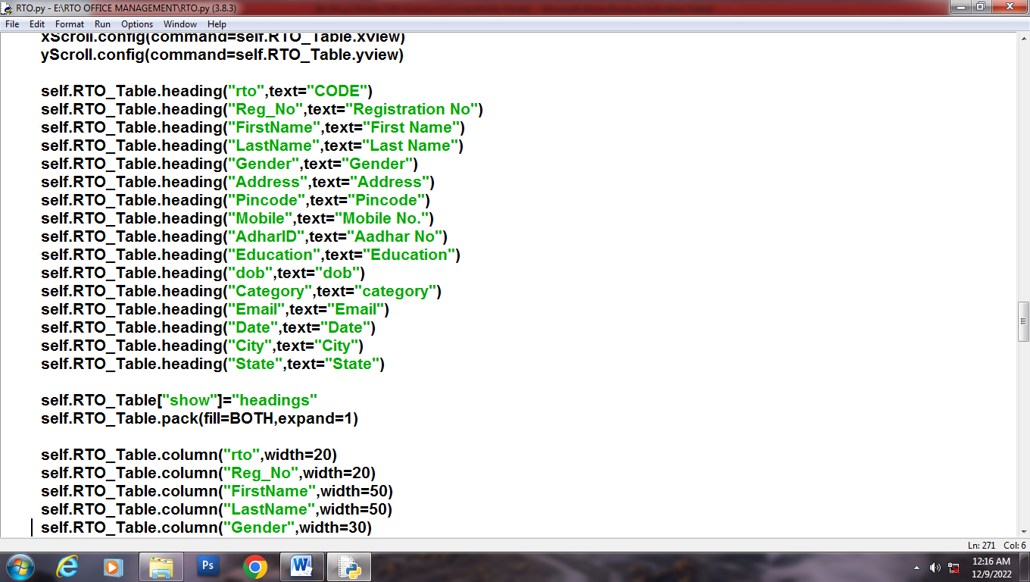

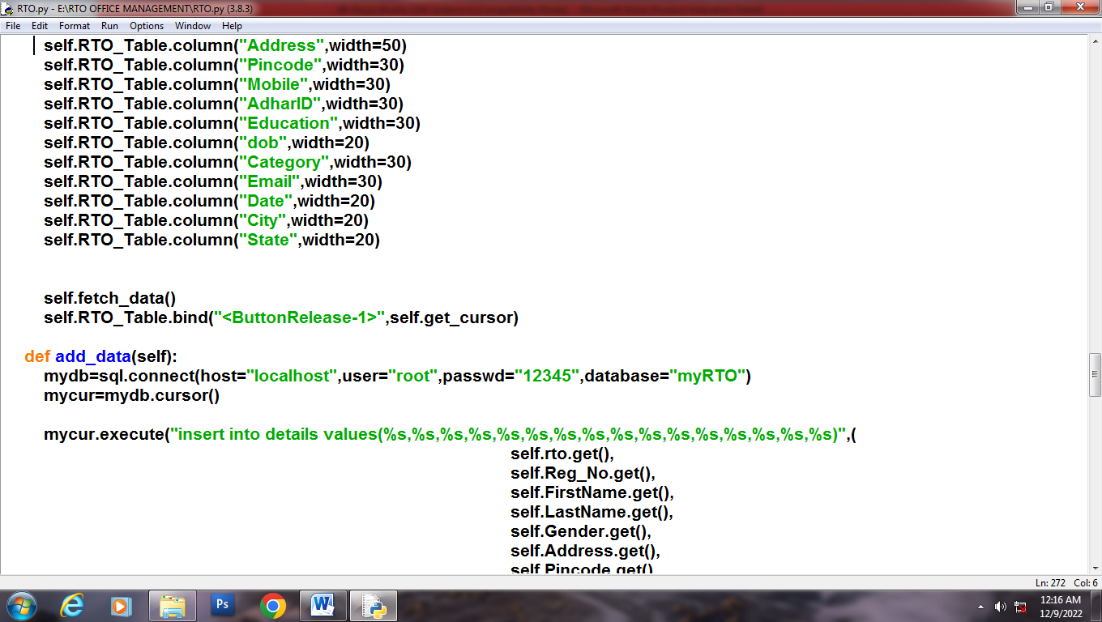

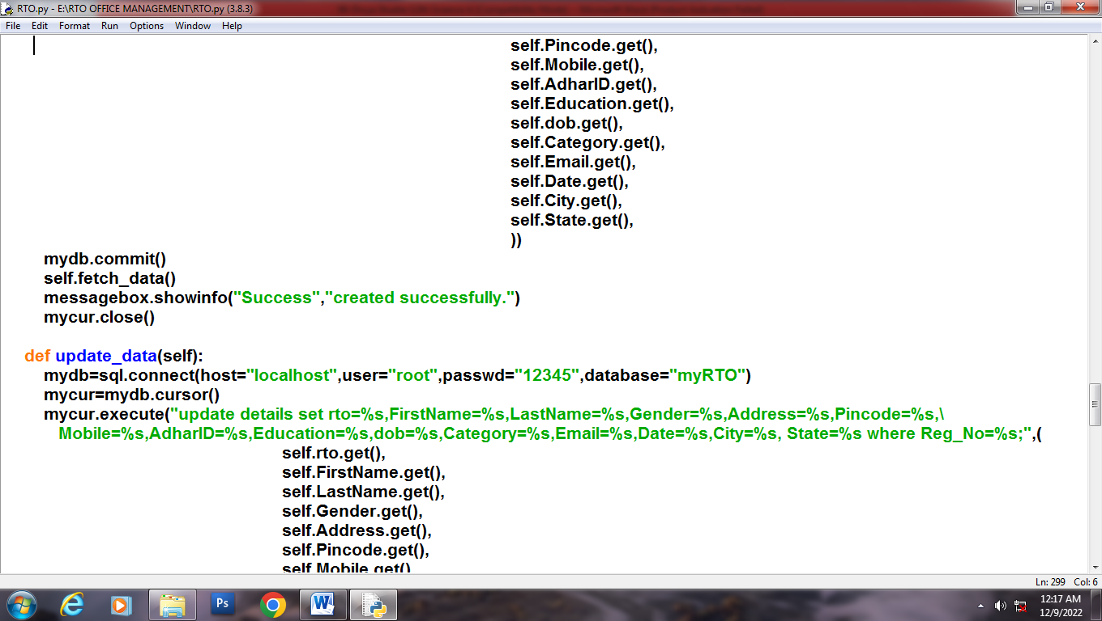

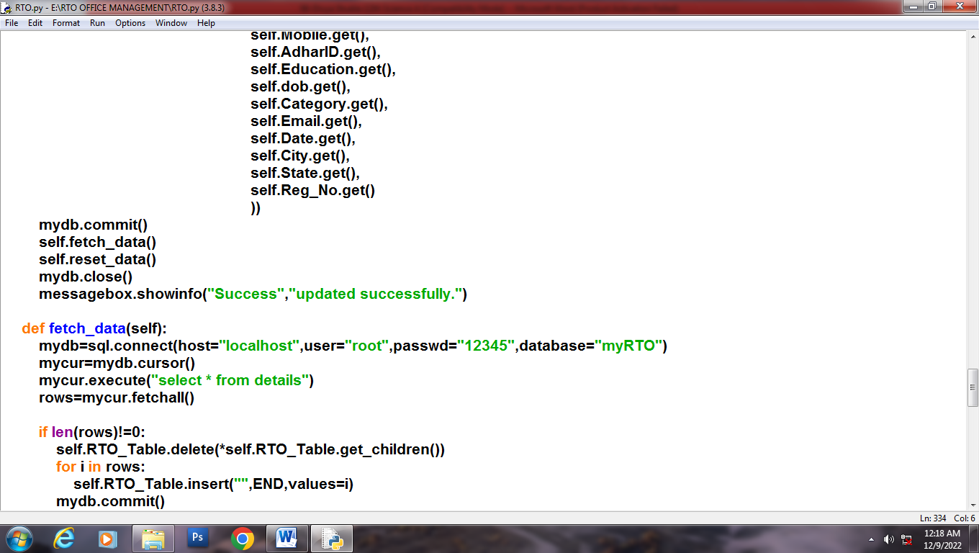

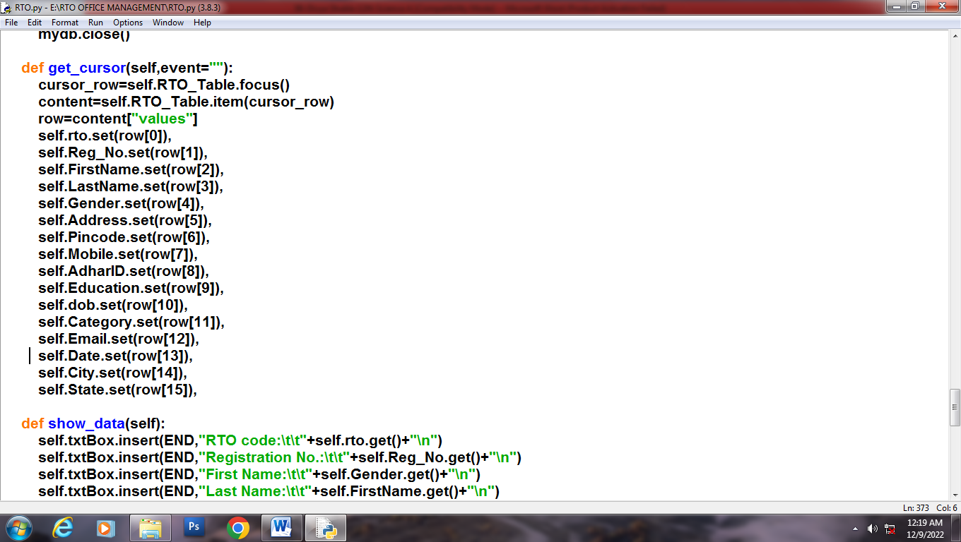

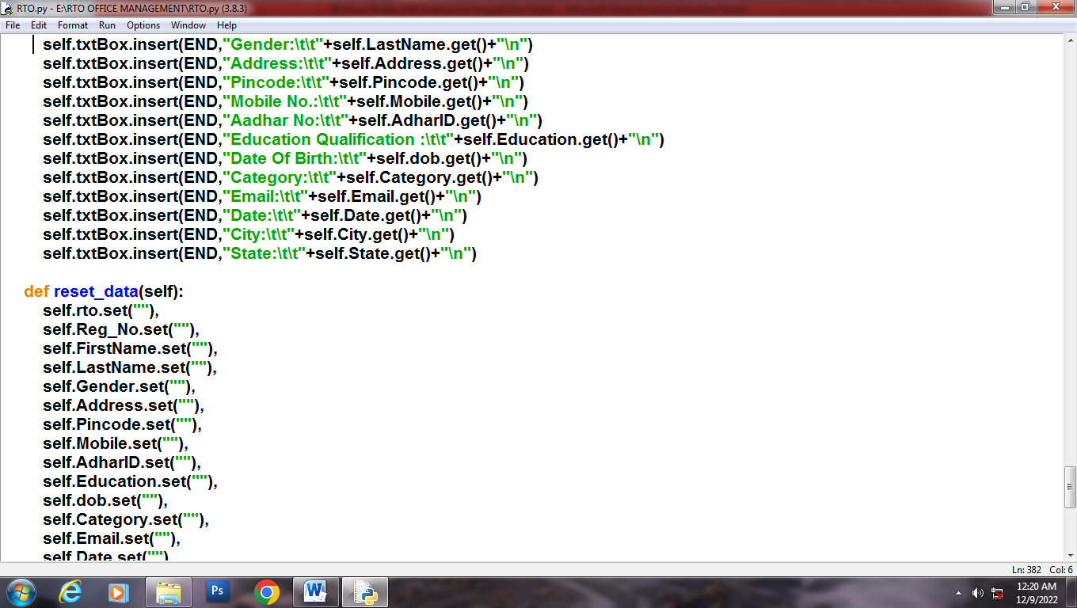

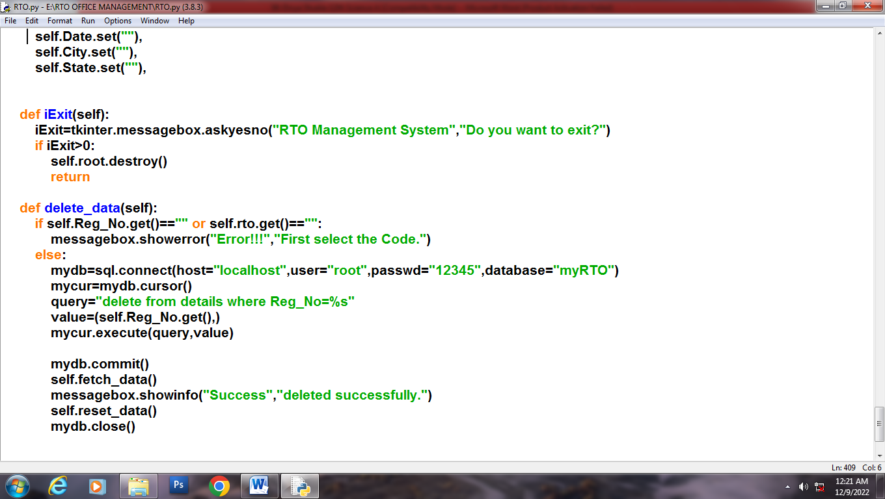

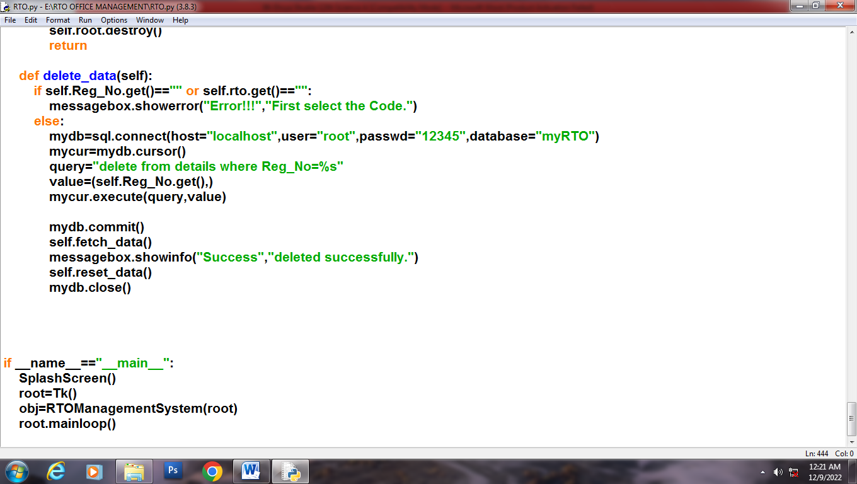

OUTPUT

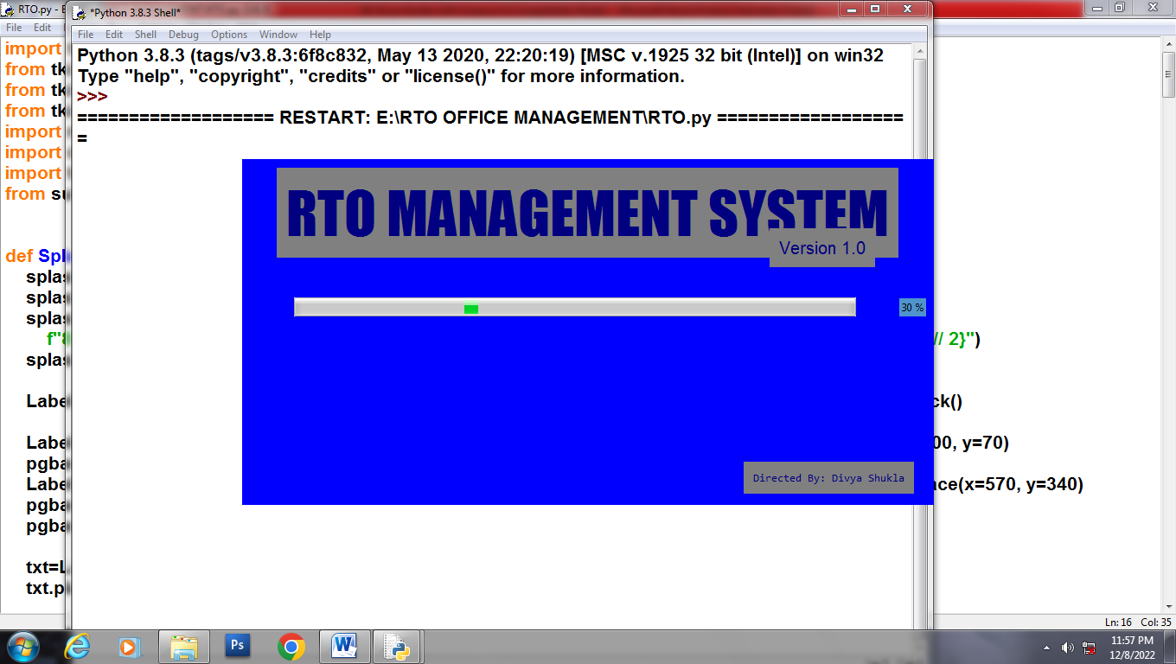

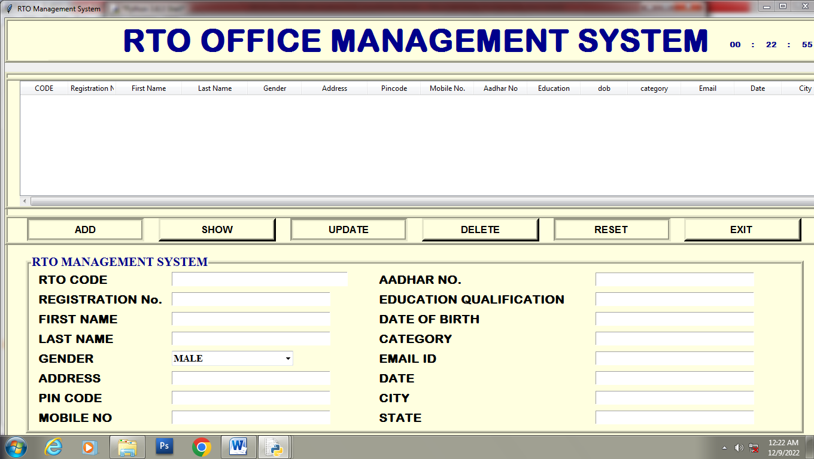

**ADD**

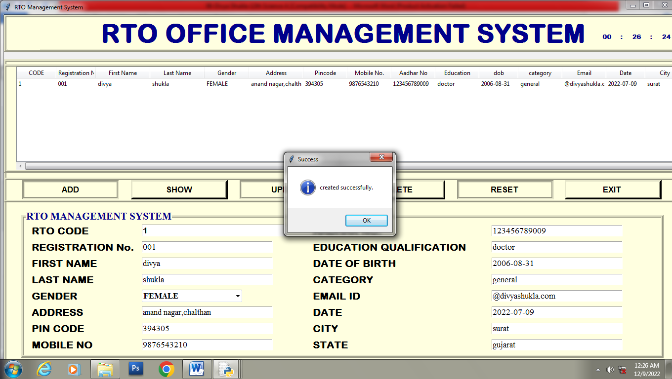

**UPDATE**

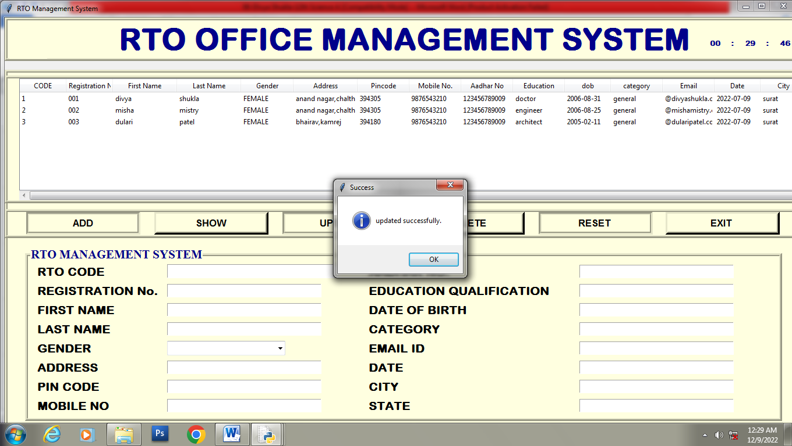

RESET

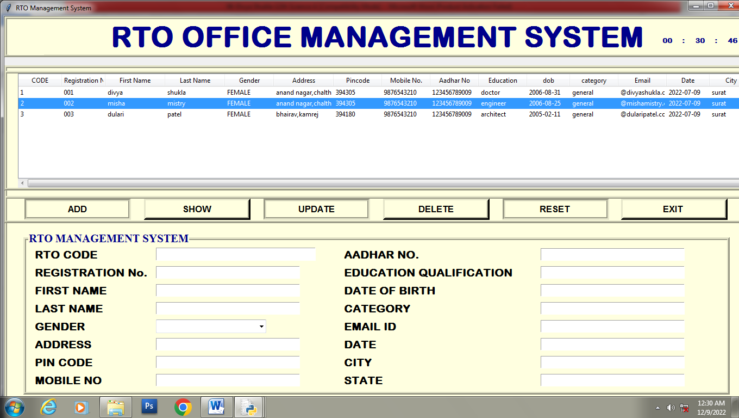

**DELETE**

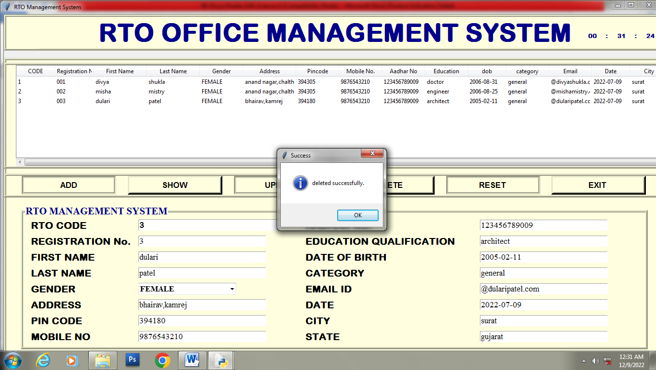

**EXIT**

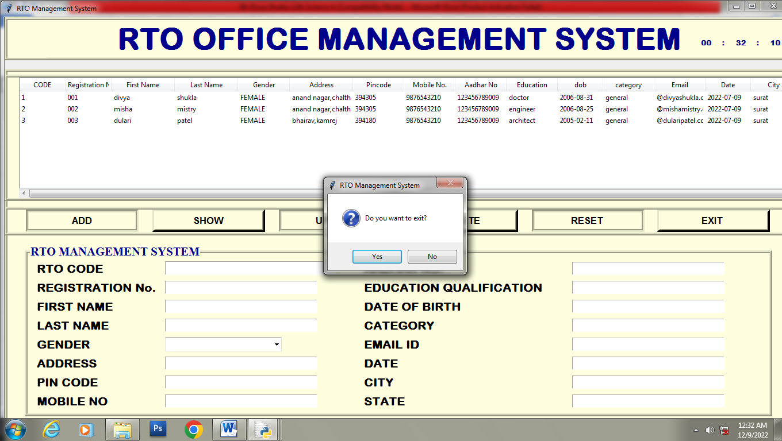

DATABASE STRUCTURE

DATABASE STRUCTURE

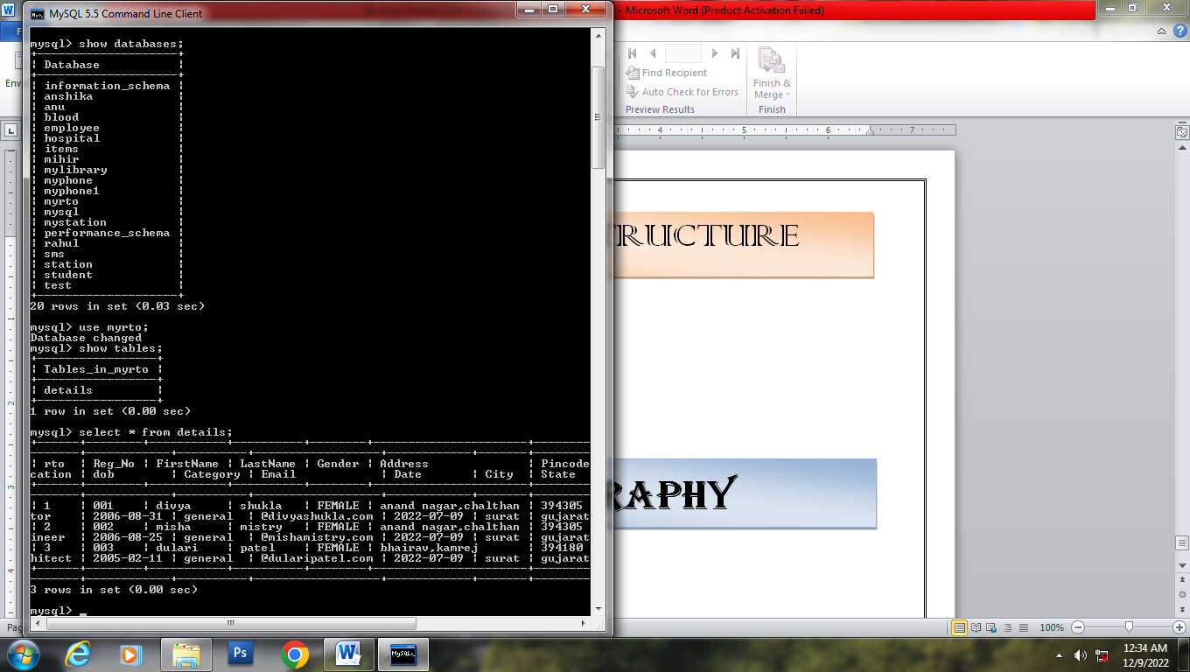

**BIBLIOGRAPHY**

1. **Computer science With Python - Class XII By : Sumita Arora**
2. **Website:** [**https://www.pythonworld.com**](https://www.pythonworld.com)

** Website:** [**https://www.xiipython.blogspot.com**](https://www.xiipython.blogspot.com)